**📌 Understanding Strings in Java**

Today, I learned about **Strings in Java**. In Java, String is a **class** present in the java.Lang package. We can create a String in two ways, and understanding how memory is managed is crucial for optimizing performance.

**1️ Using the new Keyword**

When we create a String object using the new keyword, it is stored in the **heap memory**. Two objects may be created:

1. One in the **heap memory**.
2. Another in the **String Constant Pool (SCP)** if it doesn’t already exist.

**Syntax:**

String str1 = new String("Java Programming");

**Memory Representation:**

**Heap Memory**  **:** **String Constant Pool**

**+--------------+ +-----------------------------+**

**| str1 (obj) | => | "Java Programming" |**

**+--------------+ +-----------------------------+**

1. Every time new is used, a **new object** is created in **heap memory**, even if the string already exists in SCP.
2. **Heap memory objects are subject to Garbage Collection (GC)** when they are no longer referenced.

**2️ Using String Literals**

When we create a String using **string literals**, the object is directly stored in the **String Constant Pool** (SCP).

**Syntax:**

String str2 = "Java Learn";

**Memory Representation:**

**String Constant Pool:**

**+------------------+**

**| "Java Learn" | <= str2**

**+------------------+**

1. If a **String with the same value already exists**, JVM **does not create a new object**.
2. Instead, the new reference **points to the existing object**.
3. **Strings in SCP are not garbage collected** unless explicitly removed.

**🔥 Memory Optimization & String Pool Behavior**

One major advantage of the **String Constant Pool** is its ability to **reuse objects**, thereby reducing memory consumption.

**Example:**

String str2 = "Java Learn";

String str3 = "Java Learn"; // Points to the same object as str2

**Memory Representation:**

**Heap Memory: (No new objects created)**

**String Constant Pool:**

**+------------------+**

**| "Java Learn" | <= str2**

**| | <= str3**

**+------------------+**

1. str2 and str3 **point to the same memory location**, improving efficiency.
2. This eliminates duplicate string objects, optimizing memory usage.

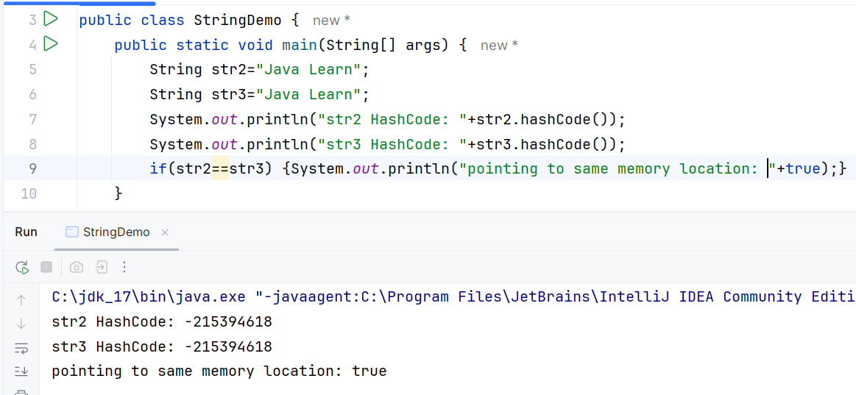

**🛠️ How JVM Handles String Pooling**

1. **When creating a string literal ("Java"):**
2. JVM **checks if it already exists in SCP**.
3. If yes, it **returns the reference** to the existing object.
4. If no, it **creates a new object in SCP**.
5. **When using new String():**
6. A **new object is always created in Heap Memory**, even if the value exists in SCP.
7. The reference in Heap Memory may point to an SCP object using .intern().

**Example with intern() Method**

String str4 = new String("Hello");

String str5 = str4.intern(); // Forces SCP reference

Heap Memory: String Constant Pool:

+--------------+ +-----------+

| str4 (obj) | -> | "Hello" | <= str5

+--------------+ +-----------+

str4 is stored in **Heap Memory**, while str5 **references the SCP object**.

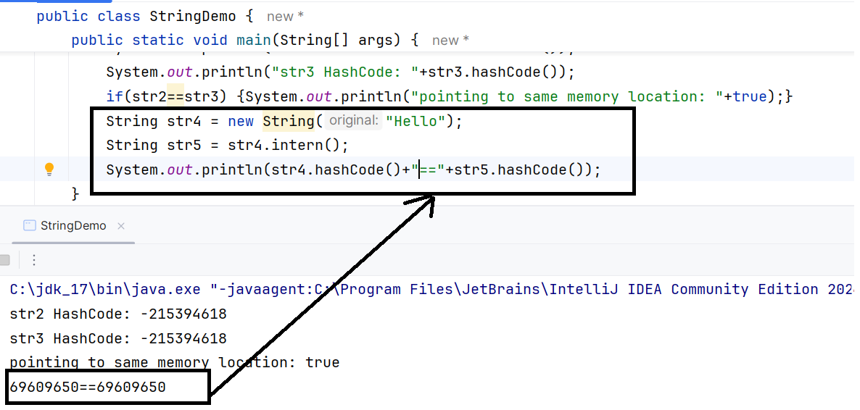

**🎯 Key Takeaways**

✅ Using new keyword **always creates a new object** in Heap Memory.

✅ String literals **reuse objects** in the **String Constant Pool**.

✅ **Garbage Collector (GC)** does not clean SCP unless explicitly removed.

✅ Using .intern() helps reference **SCP objects explicitly**.

✅ String Pool **reduces memory usage and optimizes performance**.

Let me know if you have any thoughts or improvements! 🚀